DSA0501 – QUERY PROCESSING
LAB EXPERIMENTS
NAME : R.SABARISH
REG NO : 192324092
QUESTION 1:
import pandas as pd
from google.colab import files
uploaded = files.upload()
df = pd.read_csv("departments.csv")
print("Distinct Department IDs:")
print(df["DEPARTMENT_ID"].unique())
OUTPUT : 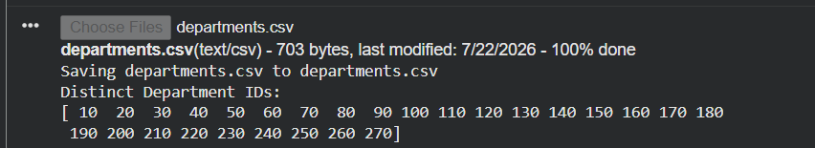

QUESTION 2:
import pandas as pd
from google.colab import files
uploaded = files.upload()
df = pd.read_csv("job_history.csv")
result = df.groupby("EMPLOYEE_ID").size()
result = result[result >= 2]
print("Employee IDs with two or more jobs:")
print(result.index.tolist())
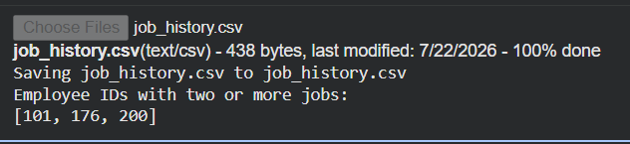
QUESTION 3:
import pandas as pd
from google.colab import files
uploaded = files.upload()
df = pd.read_csv("jobs.csv")
result = df.sort_values(by="JOB_TITLE", ascending=False)
print(result)
